SmartCare: How to find Incomplete Scans/Imports
Log-in to SmartCare
Click on the Magnifying Glass (upper left)

Type in “Scanning” in the Search box
Select “Scanning (My Office)”
Scanning screen: Select “Not Completed” in the dropdown menu
Created Between: 09/01/24 and __/__/__ (put in the date you are running the list
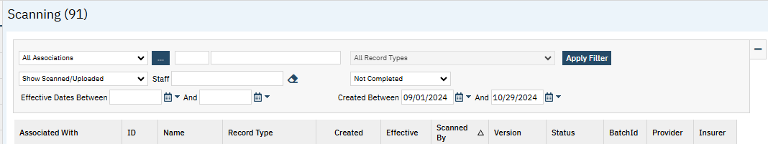
Click on the “Apply Filter” button
Then click on the “Scanned By” column header to sort by program staff
Scroll down to identify possible incomplete scans/imports by members of your program
Refer to the “SmartCare Scanning Documents Job Aid – Oct. 2024” to resolve “Not Completed” scans/imports.

